Determination of Carbamazepine in Pharmaceutical Preparations and Pure Forms Using HPLC-DAD, First Order- and Second Order- Derivative Spectrophotometric Methods
Fatma DEMİRKAYA*, Yücel KADIOĞLU*

*Department of Analytical Chemistry, Faculty of Pharmacy, Ataturk University, 25240, Erzurum, TURKEY( Tel:+90 442 2311536 ;e-mail:yucel@atauni.edu.tr)

Abstract: HPLC-DAD, First order- and Second order- derivative spectrophotometric methods were developed and validated for quantitative determination of Carbamazepine (CBZ) in three different pharmaceutical preparations. Validation parameters such as linearity, precision, accuracy, specificity, limit of detection (LOD) and limit of quantitation (LOQ) were determined according to International Conference on Harmonization guidelines. HPLC-DAD was carried out by reversed phase technique on Bondolone C₁₈ column with a mobile phase composed of acetonitrile and Milli-Q grade water (30:70, v/v) pumped at a flow-rate of 1 ml min⁻¹ at 220 nm. Spectrophotometrically, CBZ was determined by measuring the first order- derivative values at 285 nm and second order- derivative values at 287 nm. Beer’s Law was obeyed in the range 0.25-25 μg ml⁻¹ for HPLC and 1.25-25 μg ml⁻¹ for first order- and second order- derivative spectrophotometric methods. Statistical analysis by F-test showed no significant difference between the results obtained by three methods. The proposed methods are highly sensitive, precise and accurate and can be used for the reliable quantitation of CBZ in pharmaceutical preparations.
Keywords: Carbamazepine, HPLC, First order- derivative and Second order- derivative

1. INTRODUCTION
Carbamazepine (CBZ), 5-H-Dibenz [b.f] azepine-5-carboxomide (Fig.1.) is widely prescribed on an anticonvulsant, antiepileptic and antimanic drug (Olling et al, 1999). In the body, CBZ is metabolized to an active metabolite CBZ-10.11 Epoxide (CBZ-EP) which also displays anticonvulsant properties similar to these of the parent compound. CBZ is poorly soluble in aqueous media and has a high oral bioavailability in humans (Jung et al, 1997).
Several Methods have been reported for the determination of CBZ standarts and in pharmaceutical preparations including Spectrophotometric Methods (Riad et all, 1986, Camara et all, 2005, Rezaei et all, 2005), Spectrofluorimetry Methods (Huang et all, 2002, Fellenberg et all, 1976), Gas-Liquid Chromatograpy (GC) [Frigerio et all, 1973, Chen et all, 1991), FT-Raman Spectroscopy (Auer et all, 2003), Liquid Chromatograpy [Mohammed, 2000, Manoj Babu, 2004, Lam et all, 2004, González-Barreiro et all, 2003). But there isn’t any Derivative UV Spectrophotometric Methods for the determination of CBZ in pharmaceutical preparations. Derivative UV spectroscopy has been widely used as a tool for quantitative analysis, characterization, and quality control in agricultural, pharmaceutical, and biomedical fields. This technique offers various advantages over the conventional absorbency methods such as the discrimination of the sharp spectral features over the large bands and the enhancement of the resolution of overlapping spectra (Wang et all,2000, El-Gindy et all, 2000). The aim of this study was to develop a HPLC method and an alternative derivative Spectrophotometric method, to the more time consuming HPLC method, which can be used regularly and for formulation screening. HPLC-DAD, first order- and second order- derivative spectrophotometric methods that could be used for determination of CBZ in pure forms and in pharmaceutical preparations were developed and validated. The results obtained from these methods were statistically compared. Statistical analysis (F-test) showed no significant difference between the results obtained with three methods.

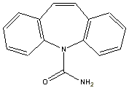

Fig.1.Chemical structure of Carbamazepine.

2. EXPERIMENTAL

2.1. Materials and Chemicals
CBZ was kindly supplied by Novartis (Turkey). HPLC grade and analytical grade methanol and acetonitrile were purchased from Merck (Germany). The water of HPLC was prepared by double glass distillation and filtration through Millipore 0.45 μm. white nylon HNWP 47 mm filters.
Three commercial preparations were used in assay including; Tegretol tablet (Novartis Pharmaceuticals, Turkey) containing 200 mg CBZ per tablet, Karberol tablet (Munir Sahin Pharmaceuticals, Turkey) containing 200 mg CBZ per tablet and Karbelex tablet (Liba Pharmaceuticals, Turkey) containing 300 mg CBZ per tablet
2.2. Spectrophotometric Assay
A Thermospectronic (HEλIOSβ) double-beam UV-Visible spectrophotometer with a Vision 32 software data processing system was used. Derivative spectra of the solutions were recorded in 1 cm quartz cells at a scan speed of 600nm/min, a scan range of 270-320 nm, fixed slit width of 2 nm and derivation interval (Δλ) 21.0 nm.

2.3.Chromatographic Assay
The CBZ analyses were performed on a Thermoseparation Spectra HPLC system consisting of a UV 6000 LP photodiode array detector, Series P 400 gradient pump and a Thermoseparations As 3000 autosampler. Isocratic elution was carried out at a flow-rate of 1 ml min⁻¹ with the mobile phase containing acetonitrile-Milli-Q grade water (30:70 v/v) pumped through a Phenomenex Bondolone reversed-phase C₁₈ column (150 x 3.9 mm. 5 μm. “USA”) The injection volume was 10 μl and the peaks were detected at 220 nm. Retention time of CBZ was 8.2 min and the total run time for an assay was approximately 9 min.

2.4. Preparation of Standard Solutions
Standard stock solution of CBZ was prepared with methanol to a concentration 50 μg ml⁻¹ and stored at 4°C. The solution was stable for at least 2 month when kept in refrigerator. The working standard solutions were prepared by dilution of different volumes of the stock solution to a constant volume with methanol to reach a concentration range of 1.25-25 μg ml⁻¹. First order- and second order- derivative curves of working standard solutions were scanned 270-320 nm against a similarly prepared blank. Calibration graphs of first order- and second order- derivative (N=9. Δλ=21.0 nm) spectrophotometric methods was determined by plotting the absorbances versus CBZ concentration at 285 nm and 287 nm respectively.
For HPLC-DAD analysis, 0.25-25 μg ml⁻¹ working solutions were also prepared from stock solution and diluted by mobile phase. Working solutions were prepared freshly in analysis daily. The solutions were filtered through a phenomenex membrane of 0.45 μm pore size (25 mm filter) and transferred to an autosampler vial for analysis. Calibration graphs were prepared by using peak-area versus concentrations of CBZ in the solutions.

2.5. Analysis of Pharmaceutical Preparations
Twenty tablets of each drug (Tegretol®. Karberol® and Karbelex® tablets) were weighed and finely powdered. A portion of the powder, equivalent to about 10 mg CBZ for each drug, was accurately weighed, transferred into 50 ml volumetric flask and dispersed in 40 ml methanol. The flask was placed in ultrasonic bath for 15 min. The resulting suspension was diluted to volume with methanol and filtered. Further dilutions were performed to suit the calibration graphs for the HPLC-DAD, first order- and second order- derivative spectrophotometric methods.

2.6. Method Validation
The methods were validated according to International Conference on Harmonisation guidelines (Commision of the European Communities, 1996) for validation of analytical procedures. All statistical calculations were performed with the Statistical Product and Service Solutions (SPSS) package for windows, version 10.0 Correlations were considered statistically significant if calculated P values were 0.05 or less.

3. RESULTS AND DISCUSSION

3.1. The First Order- and Second Order- Derivative Spectrophotometric Methods
To develop a sensitive the first order- and second order- derivative spectrophotometric method, various solvent systems were tried, such as water, methanol and acetonitrile individually or in combinations of different proportions. The final decision of using methanol was based on sensitivity, interference, easy of preparation, suitability for drugs, content estimation and cost in that order.
The first order- derivative spectrum and second order- derivative spectrum of CBZ standard solutions are shown Fig.2A and 3A, respectively. Spectra with higher order of derivation had lower sensitivity and linearity, and because of this, first order- and second order- derivative spectra were selected for quantitative analysis. The first order- and second order- derivative spectrum of solutions of pharmaceutical preparations containing CBZ presence of interfering compounds in tablet formulations are also given Fig.2B-D and 3B-D. For the determination of CBZ in pharmaceutical dosage forms, the peak-to-peak amplitudes in the first-order and second order- derivative spectra at 285 nm and 287 nm, respectively, (peak-to-peak amplitude) was measured with a good sensitivity and linearity. The values of the first-order and second order- derivative concentration of citied drugs can be directly calculated since first-order and second order derivative measurement cancels the irrelevant absorbance due to the excipients in pharmaceutical dosage forms.
In general, the characteristic profiles of the derivative spectra may constitute a specific fingerprint useful for the drug identification the ratios, in particular, between the amplitudes at selected wavelength can be regarded as suitable parameters which are useful to confirm the drug identity, purity and stability.
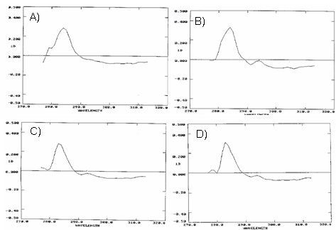

Fig.2. Firs order- derivative spectra of 10 μg ml⁻¹ CBZ: A) Standard B) Tegretol C)Karbelex D)Karberol

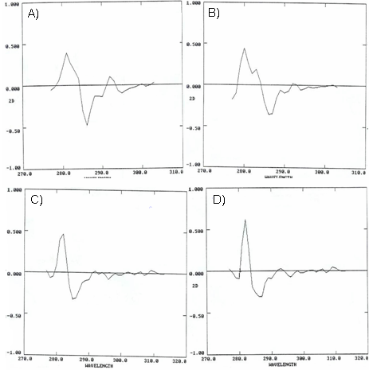

Fig.3. Second order- derivative spectra of 10 μg ml⁻¹ CBZ: A) Standard B) Tegretol C)Karbelex D)Karberol

3.2. HPLC-DAD Method
In order to evaluate the results of the absorption (zero-order) UV and the first-order derivative spectrophotometric methods, a HPLC-DAD procedure was developed. The development of the HPLC-DAD method for the determination of drugs has received considerable attention in recent years because of their importance in routine quality control analysis. A reversed-phase HPLC-DAD method was proposed as a suitable method for the estimation of CBZ in pharmaceutical dosage form. The chromatographic conditions were adjusted in order to provide a good performance of the assay. The method involved a Phenomenex Bondolone reversed-phase C₁₈ column and a mobile phase consisting of acetonitrile- Milli-Q grade water (30:70 v/v). The mobile phase was chosen after several trials with other solvent combinations. Mobil phase selection was based on peak parameters (symmetry, tailing), run time easy of preparation and cost. Fig.4A-D shows a typical chromatogram obtained from the analysis of a standard and solution of commercial CBZ using the proposed method. As shown in this figure, CBZ was eluted forming symmetrical peak and well separated from the solvent front. Observed retention time (8.2 min) allows a rapid determination of the drug. System suitability parameters calculated under the optimized experimental conditions were; capacity factor (k’) 4.46; symmetry factor 1.05 and column efficiency (n) 4303 plates /m.
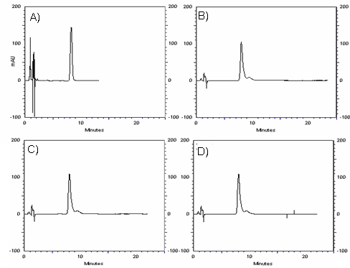
Fig.4. HPLC chromatogram of 10 μg ml⁻¹ CBZ: A) Standard B) Tegretol C)Karbelex D)Karberol

3.3. Validation of the Proposed Methods

3.3.1 Linearity
To determine the linearity of HPLC-DAD, first order- and second order- derivative spectrophotometric methods, calibration standard solutions of CBZ were prepared as in the text. The linear ranges were found to be 0.25-25 μg ml⁻¹ for HPLC and 1.25-25 μg ml⁻¹ for first order- and second order- derivative spectrophotometric methods. Linearity was estabilished by least-squares regression analysis. The correlation coefficients, r, for HPLC-DAD, first order- and second order- derivative spectrophotometric methods were 0.9995, 0.9840 and 0.9850 (n=6) (Table 1).

Table 1: Results of regression analysis of data for the quantitation of CBZ by the proposed methods (n=6)
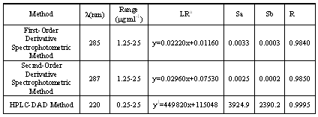
λ: wawelength, ªBased on six calibration curves, LR: linear regression, Sa: Standard deviation of intercept of regression line Sb: Standard deviation of slope of regression line, R: Coefficient of corelation, y: Absorbans, y¹: Peak-area,x: Carbamazepine concentration (μg ml⁻¹)

3.3.2.Stability
The stability of CBZ was determined with HPLC method. For the determination of the stability of CBZ in solution at ambient 4ºC and -20ºC refrigeration temperature, three sets of low (2.5 μg ml⁻¹ ), medium (7.5 μg ml⁻¹) and high (15 μg ml⁻¹) concentrations were divided into 12 tubes. One set was assayed immediately and taken as standard (100 %). One of the sets was stored at a temperature of 4ºC for 24 h and 1 week. Other set was stored at a temperature – 20ºC in a deepfeezer for 24 h. The remaining set was allowed to stand at ambient temperature for 24 h. Then the stability measurements were carried out. The results were evaluated comparing these measurements with those of standards and expressed as percentage deviation. They are summarized in Table 2.

Table2:Stability of CBZ in solution. 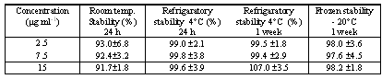

3.3.3. Accuracy and Precision
The precision of the proposed method was determined by repeatability (within-day) and intermediate precision (between-day). The precision study was examined by analysing three different samples (2.5, 7.5 and 15 μg ml⁻¹, quality control samples) by only one operator. The repeatability was evaluated by analyzed six time within one day, whereas intermediation precision was evaluated by analyzed once daily for six days. The precision of HPLC-DAD, first order- and second order- derivative spectrophotometric methods were demonstrated by RSD % of lower than 6,68, 9,64, 9.56 %, respectively. These data are summarised in Table 3
To determine the accuracy of the proposed methods and to study the interference of formulation additives, the accuracy was checked as three concentration levels (2, 15, 25 μg ml⁻¹, quality control samples) The precision of HPLC-DAD, first order- and second order- derivative spectrophotometric methods were demonstrated by relative error % of lower than 6,0, 9,86, 11,6 %, respectively. These data are also summarised in Table 3

Table 3: Precision of the methods for determination of CBZ
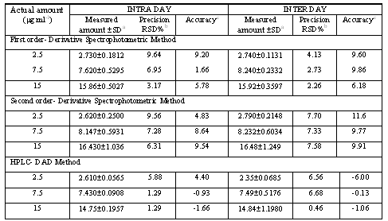
2.SDª : Standard deviation of six replicate determinations, RSD: Relative standard derivation, ^{b}Average of six replicate determinations, Accuracy^{c} : (relative error%)= (Measured amount - Actual amount )/ Actual amount x100

3.3.4. Sensitivity
LOD and LOQ were determined by an empirical method that consisted of analyzing a series of standard solutions containing decreasied amounts of CBZ. The limit of quantification (LOQ) is defined as the lowest concentration on the calibration curve at which both accuracy and precision should be within %20. LOQ and LOD values were determined to be 0.07 μg ml⁻¹ and 0,05 μg ml⁻¹ for HPLC-DAD and 0.50 μg ml⁻¹and 0,25 μg ml⁻¹ for first order- and second order- derivative spectrofotometric methods, respectively, whose precision and accuracy were well within the proposed criteria.

3.4. Comparison of the methods
The proposed analytical methods were compared using statistical analysis. The F- test was applied and did not reveal any significant difference between the experimental values obtained in the sample analysis by the three methods (Table 4). According to the statistical comparison of results, there is no significant difference between HPLC-DAD, first order- and second order- derivative spectrophotometric methods.

Table 4: Statistical evaluation of obtained data from three methods in tablets containing CBZ.
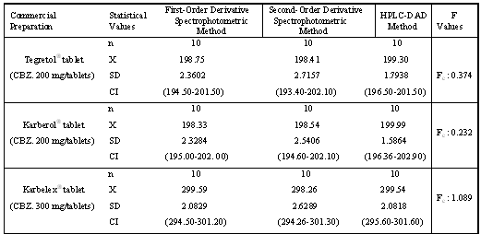n: Number of determination, ªX: mean, SD: standart deviation, CI :Confidence interval Ft: Tabulated F values (F_{t} : 3.330) Fc: Calculated F values, H_{o}: Hypothesis: no statitically significant difference exists among three methods, F_{t}> F_{c;} , H_{o} hypothesis in accepted (P <0.05).

4.CONCLUSION

The first order- and second order- derivative spectrophotometric and HPLC-DAD methods were developed and validated successfully in the quantitative analysis of carbamazepine in pure forms and in pharmaceutical preparations. The most striking features of derivative spectrophotometric methods described here are their simplicity and rapidity, no requiring time-consuming sample preparation such as filtration, degassing that are need for HPLC procedure and also chromatographic methods need expensive equipment. The assay results obtained these three methods are in intended agreement. The described derivative spectrophotometric methods are an excellent alternative to HPLC method for determination of the CBZ in tablet or a corresponding mixture and all the reported methods can be used for the routine quality control analysis of the investigated drug in pharmaceutical preparations.

REFERENCES
Auer, M.E., U.S. Griesser, J. Sawatzki, Qualitative and quantitative study of polymorphic forms in drug formulations by near infrared FT-Raman spectroscopy. Journal of Molecular Structure, 661: 307-317.
Camara, M.S., C. Mastandrea, H.C. Goicoechea (2005). Chemometrics-assisted simple UV-spectroscopic determination of carbamazepine in human serum and comparision with reference methods. J.Biochem Biophys.Methods, 64: 153-166.
Chen, K., K.K. Bashi (1991) Comperative analysis of antiepileptic drugs by gas chromatography using capillary or packed columns and by fluorescens polarization immunoassay, Analytical Toxicol, 15: 82-85.
Fellenberg, A.J., and A.C. Pollard (1976). A rapid spectrophotometric procedure for the simultaneous micro determination of carbamazepine and 5,5-diphenyl-hydantoin in blood. Clinica Chimica Acta, 69: 429-431.
Frigerio, A., K.M. Baker, G. Belvedere (1973). Gas chromatographic degradation of several drugs and their metabolites.Analytical Chemistry, 45: 1846-1850.
González-Barreiro, C., M. Lores, M.C. Casais, R. Cela (2003). Simultaneous determination of neutral and acidic pharmaceuticals in wastewater by high-performance liquid chromatography–post-column photochemically induced fluorimetry, Journal of Chromatography A, 993: 29-37.
Huang, C., Q. He, H. Chen (2002). Flow injection photochemical spectrofluorimetry for the determination of carbamazepine in pharmaceutical preparations. Journal of Pharmaceutical and Biomedical Analysis, 22: 59-65
Jung, H. R.C. Milan, M.E. Girard, F. Leon, M.A. Montoya (1997). Bioequivalence study of carbamazepine tablets: in vitro/in vivo correlation. Int. J. of Pharmaceutics,152: 37-44.
Lam, M.W., C.J. Young, R.A. Brain, D.J. Johnson, M.A. Hanson, C.J. Wilson, S.M. Richards, K.R. Solamon, S.A. Mabury (2004). Aquatic persistence of eight pharmaceutical in a microcom study. Toxicology and Chemistry, 23: 1431-1440.
Manoj Babu, M.K. (2004). Simultaneous separation and quantitation of four antiepileptic drugs a study with potential for use in patient drug level monitoring. Journal of Pharmaceutical and Biomedical Analysis, 34: 315-324.
Mohammed, E.A.H.(2000). Comparative LC–MS and HPLC analyses of selected antiepileptics and beta-blocking drugs. Il Farmaco, 55: 136-145.
Olling, M., T.T. Mensinga, D.M. Barends, C. Groen, O.A. Lake, J. Meulenbent (1999). Bioavailability of carbamazepine from four different products and the occurrence of side effects. Biopharmmaceutics and Drug Disposition, 20:19-28.
Rezaei, Z., B. Hemmateenejad, S. Khabnadideh, M. Gorgin (2005). Simultaneous spectrophotometric determination of carbamazepine and phenytoin in serum by PLS regression and comparison with HPLC. Talanta, 65: 21-28.
Riad, L.E., K.K. Chan, W.E. Wagner, R.J. Sawchuk (1986). Simultaneous first and zero-order absorption of carbamazepine tablets in humans. Journal of Pharmacological Sciences, 75: 897-900.
Validation of Analytical Procedures, Proceedings of the International Conference on Harmonisation (ICH), Commision of the European Communities, 1996.

