A VERSATILE CALIXARENE DERIVATIVE FOR TRANSPORTATION SYSTEMS AND SENSOR TECHNOLOGY

Shahabuddin Memon*, Mansoor Ahmed Qazi, Imdadullah Qureshi and I. B. Solangi

National Center of Excellence in Analytical Chemistry, University of Sindh,
Jamshoro-76080-Pakistan

Abstract
Calixarenes are a readily available and important class of macrocycles in supramolecular chemistry. They can easily be prepared by base-induced condensation of certain p-substituted phenols with formaldehyde. Calixarenes have generated considerable interest due to their basket shaped structure and as useful building blocks to synthesize selective receptors for the guest species, notably alkali/alkaline earth, lanthanide and transition metal cations [1-3]. Chemosensors for metal ions have both receptor and reporter contributions that act in a complementary manner. However, during the last three decades calixarene chromoionophores have long been studied as specific metal ion indicators. Various types of chromogenic calix[4]arene derivatives have recently been synthesized which have shown selective recognition and complexation with metal ions [4-6].

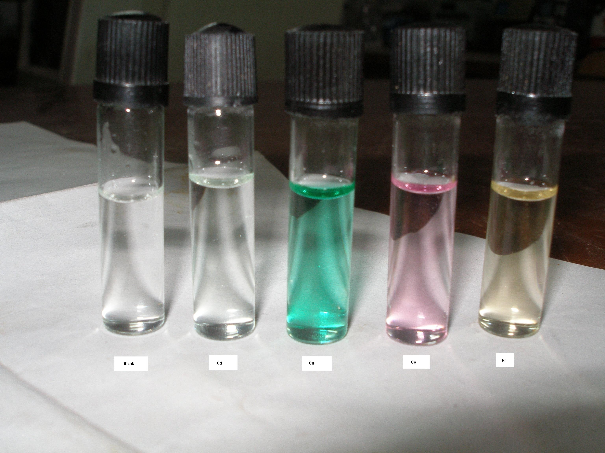

Herein, we explore the versatile nature of calixarene derivative in two-phase extraction system for the removal of metals as well as its chemosensor properties.

Keywords: Calixarene, Supramolecular chemistry, Chemosensor, Metal ions, Chromoionophore.

References

[1] C.D Gutsche, in: J.F. Stoddart. (Ed.), Calixarenes Revisited, Royal Society of Chemistry, Cambridge, England, 1998.
[2] S. Memon, M. Yilmaz, D.M. Roundhill, Collect. Czech. Chem. Commun. 69 (2004) 1231.
[3] H. Korkmaz Alpoguz, S. Memon, M. Ersoz, M. Yilmaz, Sep. Sci. Tech. 40 (2005) 2365.
[4] S. Erden, A. Demirel, S. Memon, M. Yılmaz, E. Canel, E. Kılıc, Sens. Actuators B Chem.113 (2006) 290.
[5] M.D. Barkovskaya, D.M. Roundhill, S. Memon, M.I. Bhanger, M. Yilmaz, Pak. J. Anal. Environ. Chem. 8 (2007) 1.
[6] A.G. Uysal, S. Memon, D. Erol, S. Aslan, M. Yilmaz, React. Funct. Polym. 68 (2008) 125.

