MOLECULAR STRUCTURE AND VIBRATIONAL FREQUENCES OF 1, 2, 3– TRICLORO 4- NITROBENZENE BY HARTREE–FOCK AND DENSITY FUNCTIONAL THEORY CALCULATIONS

Salih Cınaklı ª, Yusuf Sert ª, Mustafa Böyükata ª, Fatih Ucun ^{b}

ª Department of Physics, Faculty of Arts and Sciences, Bozok University, Yozgat, Turkey
^{b} Department of Physics, Faculty of Arts and Sciences, Süleyman Demirel University, Isparta, Turkey

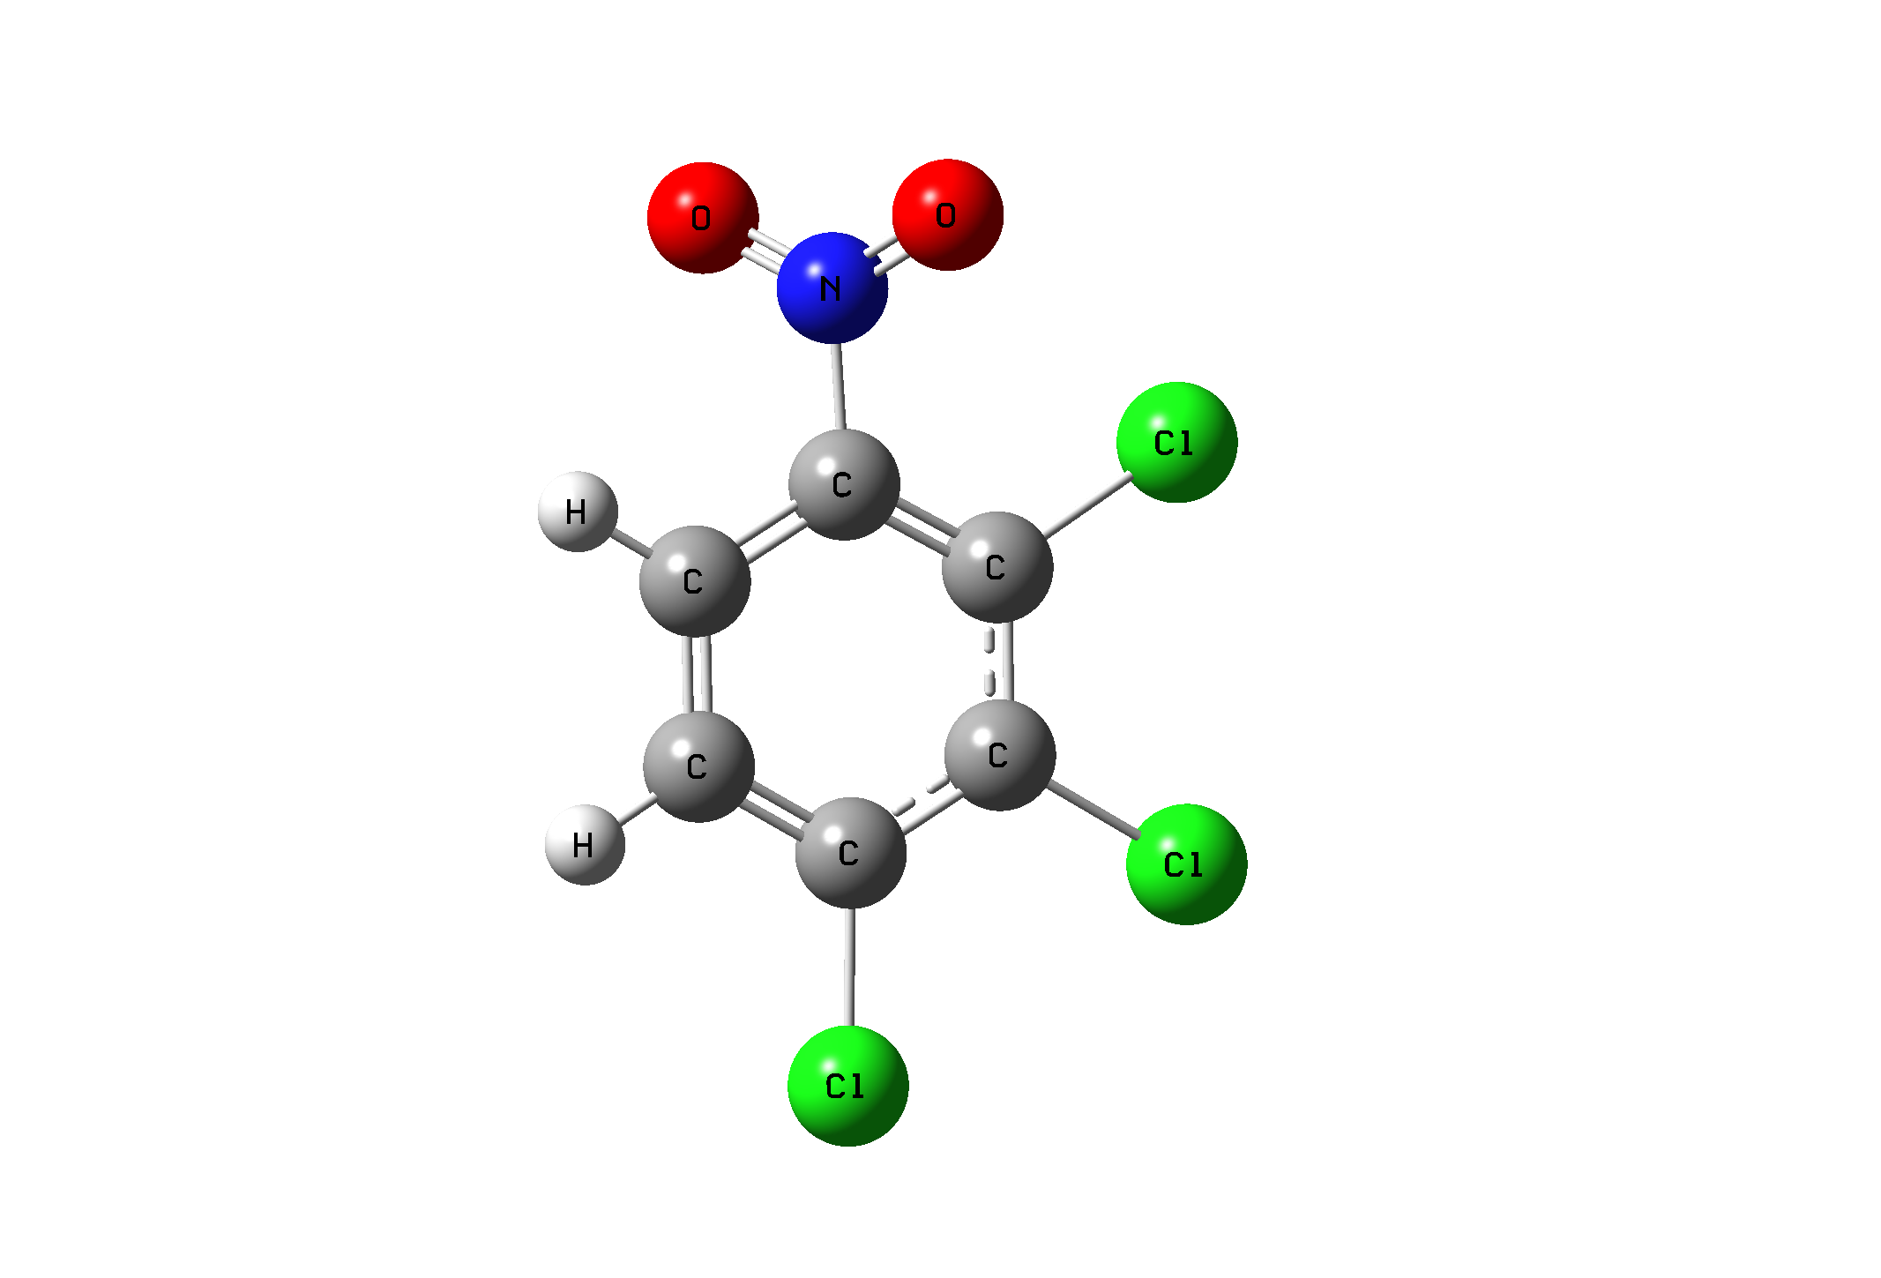
The photo electrochemical behavior of several chlorinated nitro benzenes has been investigated using steady state channel flow cell methods [1]. The molecular structure (Fig.1), vibrational frequencies and corresponding vibrational assignments of 1, 2, 3– tricloro 4– nitrobenzene has been calculated using ab initio Hartree-Fock (HF) and Density Functional theory (B3LYP) methods with 6-311++G(d,p) basis set level. The obtained vibrational frequencies and optimized geometric parameters (bond lengths and bond angle) were seen to be well agreement with the experimental data. The comparison of the observed and calculated results showed that B3LYP is superior to the scaled HF method.

Fig. 1. Calculated Optimized Structures of the 1, 2, 3– Tricloro 4- Nitrobenzene.

[1] G. Macfie, J. Wodhowan, and R.G. Compton, Journal of Electroanalytical Chemistry, 510, 1, 2001.

Keywords: 1, 2, 3– Tricloro 4- Nitrobenzene, Density Functional Theory, Hartree–Fock Theory.

Acknowledgement : This work was partially supported by Erciyes University Research Fund (Project No:
FBA.06.07) and in part by Bozok University.

